**COMP 3610**

**Notes for accessing Oracle Server from outside of the Lab**

* You must sign on to the TRU VPN. Use **mytruvpn.tru.ca** with your TRU network user name and password.
* You must have full network access (not just web access) after you login. Look here for more info: <http://www.tru.ca/its/students/student-remote-access.html>
* You must download and install on your laptop (home computer) **SQL Developer** from the Oracle Web site

<http://www.oracle.com/technetwork/developer-tools/sql-developer/downloads/index.html>

**for example: version 4.0.3.16 with Java Platform 1.7.0_55(noJDK) on 64 bit laptop** under Windows. If you have different Java/platform, please try different download and let the class know.

* With the TRU VPN open, start SQL Developer, use the following information to create a new Database connection:
  + your Oracle SXX account and password
  + Connection name = COMP3610 (or your own name)
  + Port: 1521 Hostname: studentdb.tru.ca 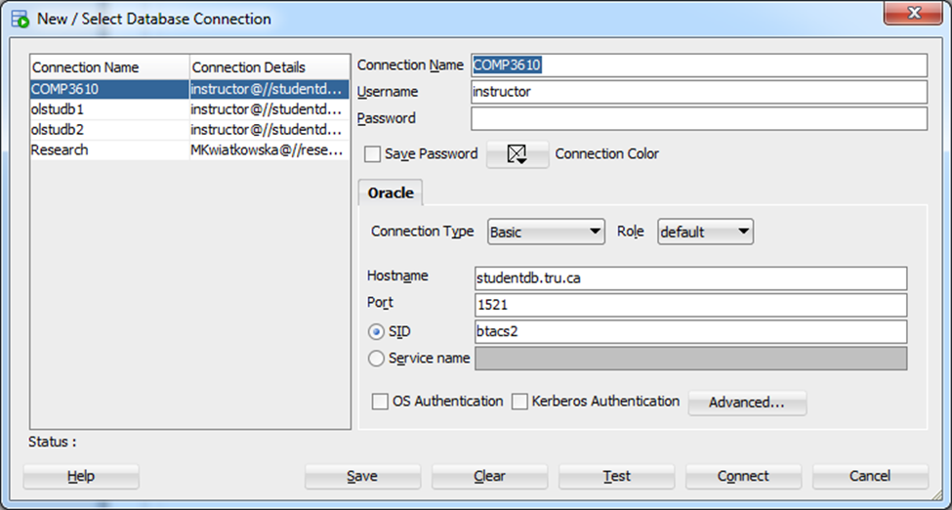Service ID: (SID) btacs2
* You may contact IT Service Desk (in Lab area or e-mail), if you have problems with Java version etc.